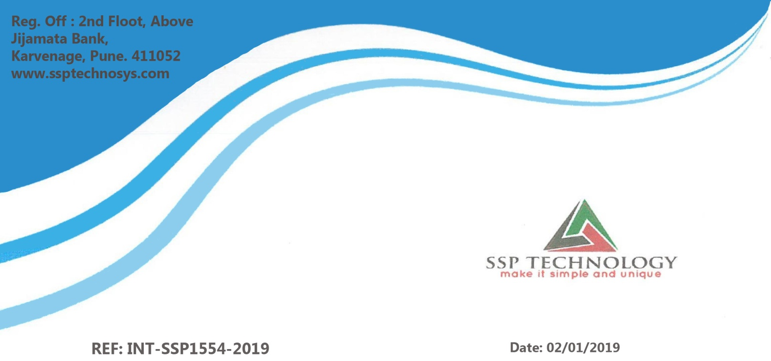

Dear **Mr. Omkar Arun Surve**,

This letter is with references to your internship application for the post of

“**Java Developer Intern**” We are happy to inform you that you have been

selected for the applied post and are offering internship position which will

be for a minimum period of **Six Month**. After further review of your

performance, you will be given a probation period





This is to certify that **Mr. Omkar Arun Surve** is undergoing industrial training

at SSP technology Pune under theguidance of **Mrs. Priyanka Marathe.**

Project Title: Noukri Hub

Duration: 9th Jan 2019 to 10th April 2019





**TO WHOM IT MAY CONCERN**

This is to clarify that **Mr. Omakr Surve** (MCA) Final year student of **Dr. D.Y. Patil Institute of MCA, Akurdi Pune** has associated with us as “**Project Intern**” From “02-Jan-2019” to till date.

As per company policy we cannot provide any kind of source code or executable to the trainee.

During his/her training period he/she was found to be sincere and effectiveness. His/Her

Conduct is exemplary and good during the project.

The candidate has worked on ”**Naukri Hub**”. The Project was carried out in partial fulfilment

Of requirement for the award of degree **MASTER OF COMPUTER APPLICATION**

(MCA) from Savitribai Phule Pune University for the Academic year 2018-2019

**We wish her every success in life.**

